Project Assignment - Final Project
ASURITE: tepadden | Website: On Deck Media
GitHub repository URL: https://github.com/tepadden/tepadden.github.io
Published website URL: https://tepadden.github.io/
Note: The final local files are packaged in tepadden-finalproject.zip. Push the local commit to GitHub before submitting if the instructor will grade the live Pages URL.
Discussion Question 1: Project purpose and topic
My final project website is On Deck Media, a videography portfolio for Thomas Padden. The purpose of the site is to present video work in a professional way, explain available filming and editing services, and give potential clients a clear path to contact me about a project.
Discussion Question 2: Target audience
The target audience includes athletes, student organizations, creators, small businesses, and individuals who need polished video content. These visitors want to quickly see examples of the work, understand the type of services offered, and find contact information without searching through social media.
Discussion Question 3: Design and content choices
The site uses a consistent dark header, blue navigation bar, white content areas, and project imagery to create a clean portfolio style. Each page has a clear title and purpose: the home page introduces the brand, the portfolio page shows work and the local video, the about page explains the creator, the services page lists prices in a table, and the contact page provides a project request form.
Discussion Question 4: Requirements completed
The website includes one home page and four content pages, all connected through the navigation. It uses header, nav, main, and footer sections, an external CSS file, meta description and keyword tags, meaningful page titles, images with alt text, one external link, an email link, a services table with three columns and three data rows, a contact form with more than four fields and action="#", and a playable HTML5 video tag on the portfolio page.
Discussion Question 7: Mechanics and final verification
I checked the spelling, grammar, navigation, media paths, and page structure before packaging the project. The local pages open correctly from the navigation, the images and video are included in the project folder, and the video file is short and small enough for Canvas upload. The GitHub repository URL is https://github.com/tepadden/tepadden.github.io and the published site URL is https://tepadden.github.io/. The newest local fixes still need to be pushed to GitHub before those URLs show every final change.
Project Requirements Checklist
Requirement | Status
Home + 3 to 5 content pages | Complete: home, portfolio, about, services, contact
HTML5 structure | Complete: header, nav, main, footer used
Table | Complete: services page has 3 columns, header row, and 3 data rows
Video tag | Complete: portfolio page uses <video> with videos/sample.mp4
External link | Complete: about page links to Sam Kolder website
Email link | Complete: footer/contact mailto link
Meta tags | Complete: every HTML page has description and keywords
Form | Complete: contact form has name, email, project type, budget, message, and submit button with action="#"
Images/media load | Complete locally: all referenced images and video are included

Required Screenshots
Screenshot 1: Home page
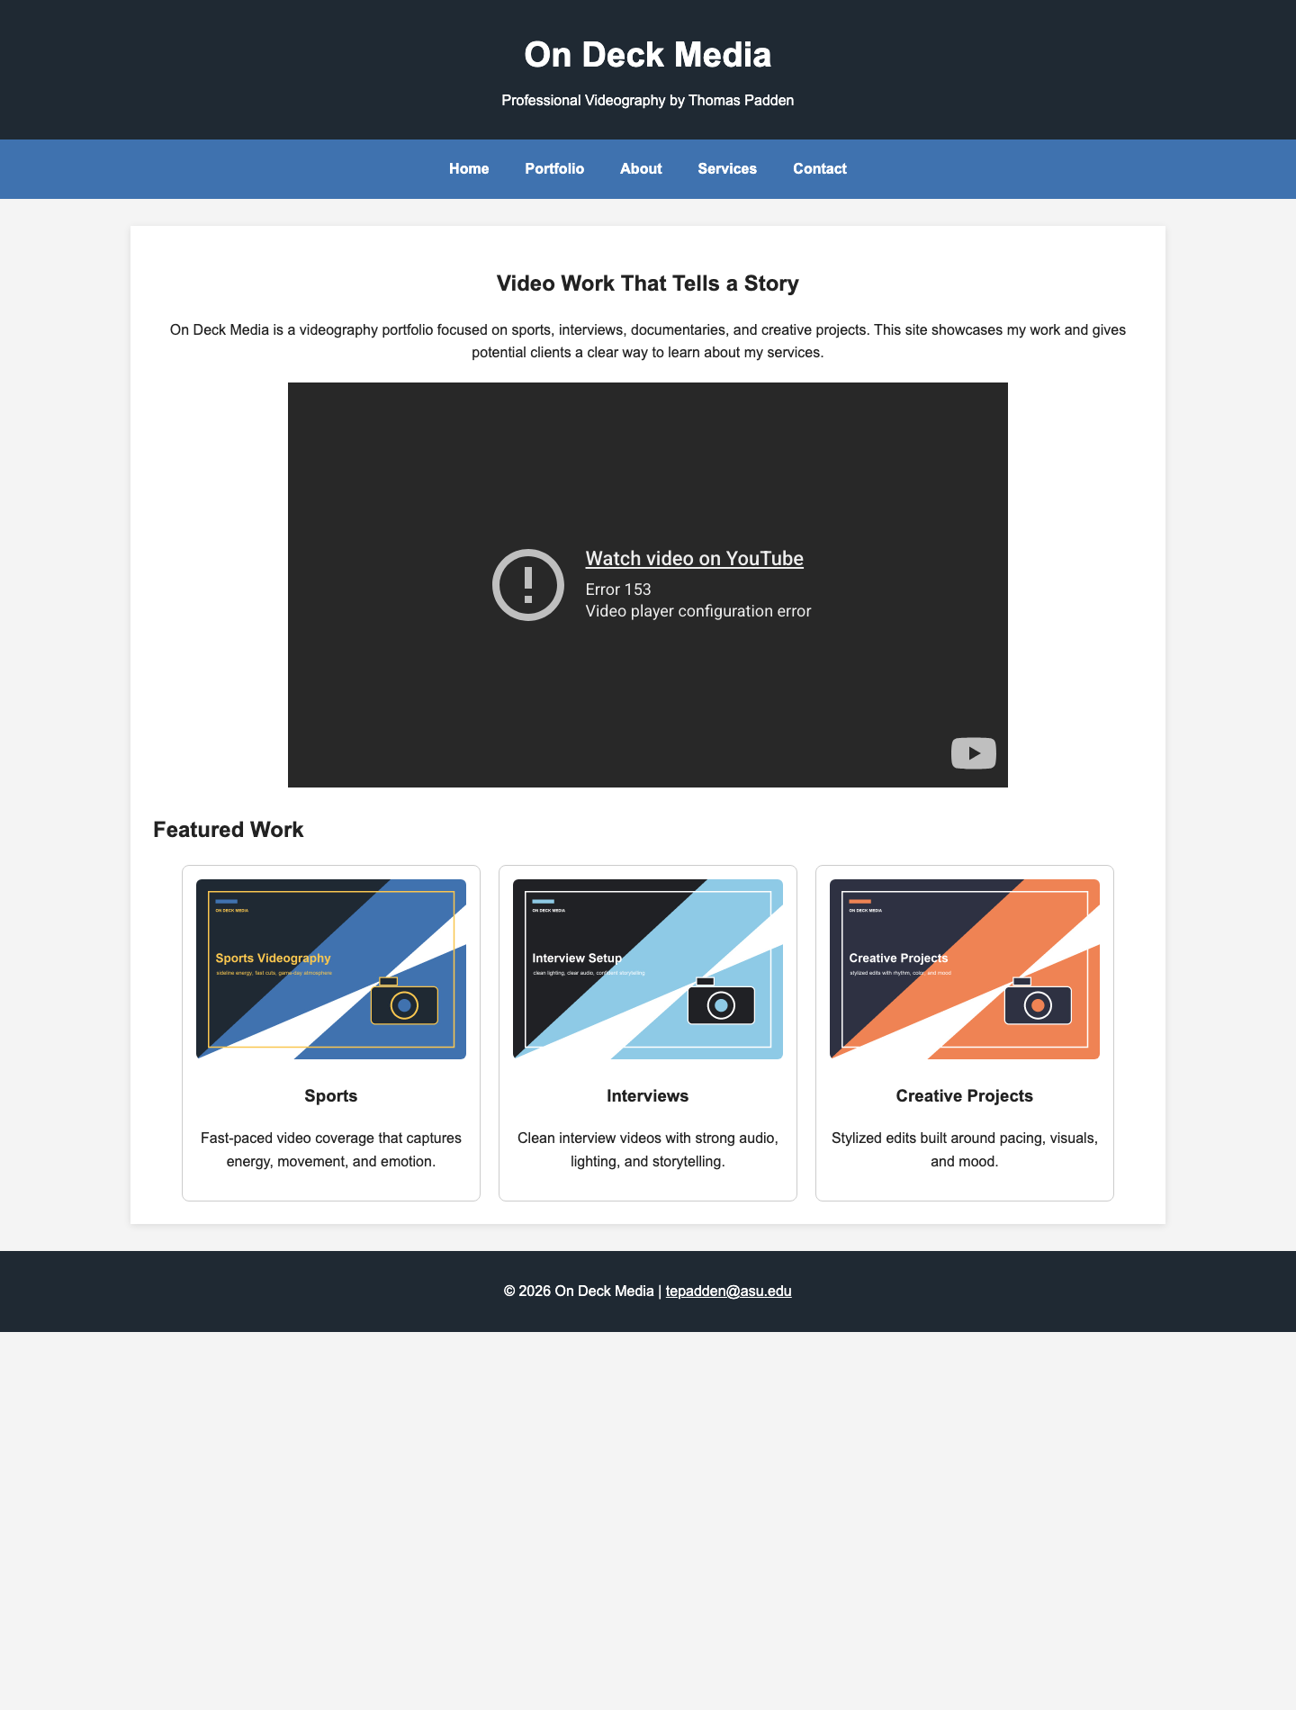
Screenshot 2: Portfolio page with HTML5 video
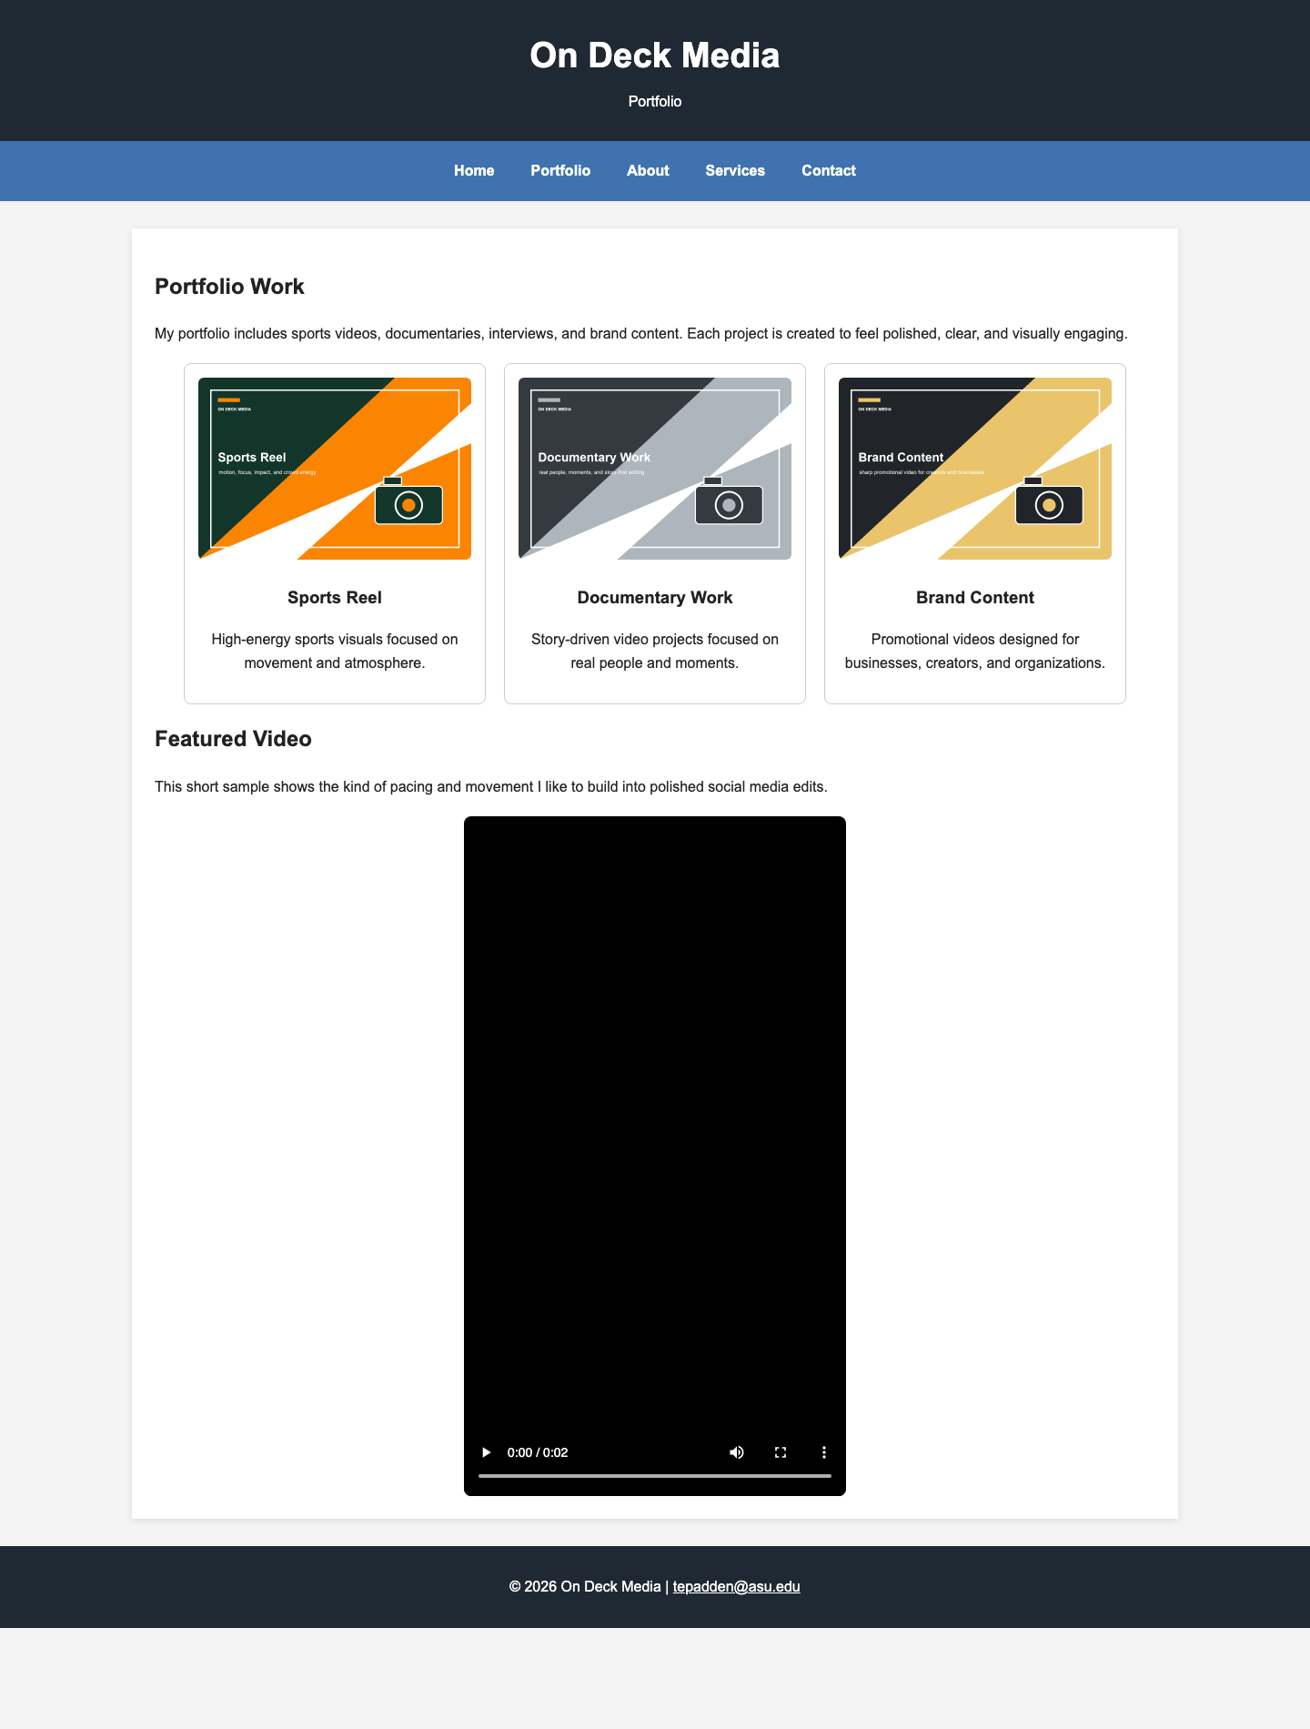
Screenshot 3: Services page with table
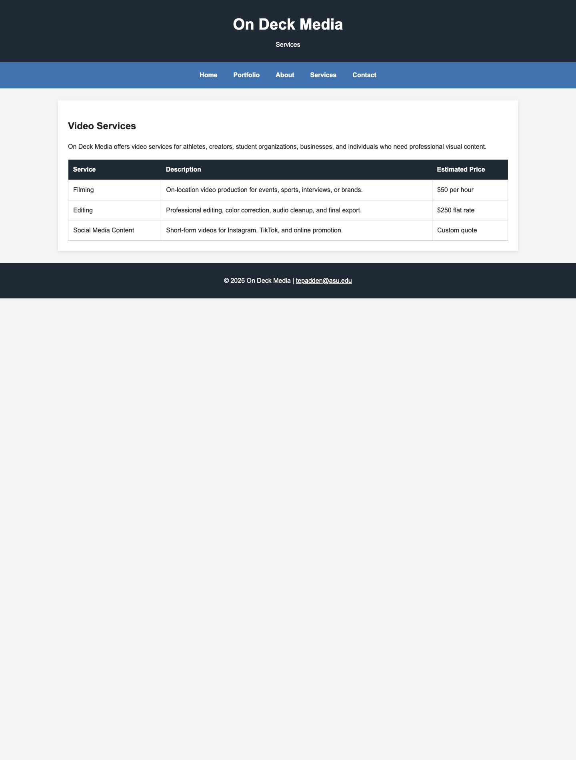
Screenshot 4: Contact page with form
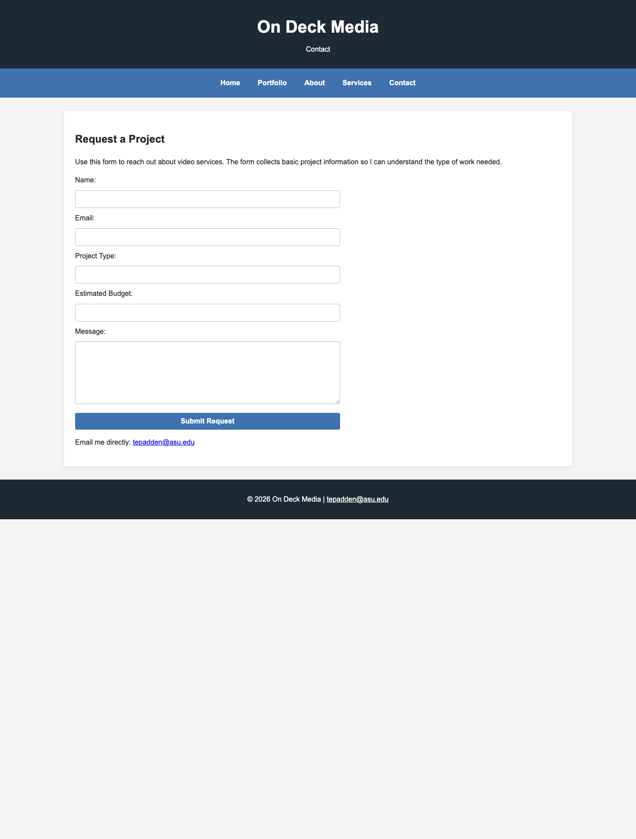
Google Analytics Realtime Overview Screenshot
This screenshot is still needed if your instructor requires the Google Analytics Realtime Overview item from the rubric. I did not fabricate this screenshot because it must come from your actual Google Analytics account.

